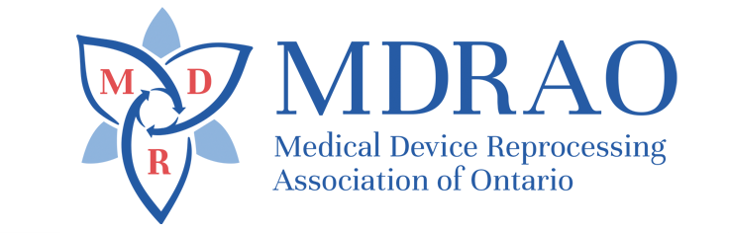

AGENDA
LAMBDA Chapter Meeting - MDRAO
Thurs. Feb. 20, 2020 – 11am EST – 10 am Central
OTN Network Event #142402139 - Conference Call - Dial 1-905-415-6667

- Call to Order
- Attendance
- Additions & Adoption of Agenda
- Last Meeting’s Minutes
- New Business:
5.1 President’s Report
5.2 Chapter Representative Report
5.3 Financial Report
5.4 Education Report
6. Education Session- Tony Leite, MDRAO Director of Chapter Development – Benefits of being a MDRAO member - then Q & A Session
7. April, 2020 @ 1pm EST - 12 noon Central - Event # 142402641
8. Adjournment

